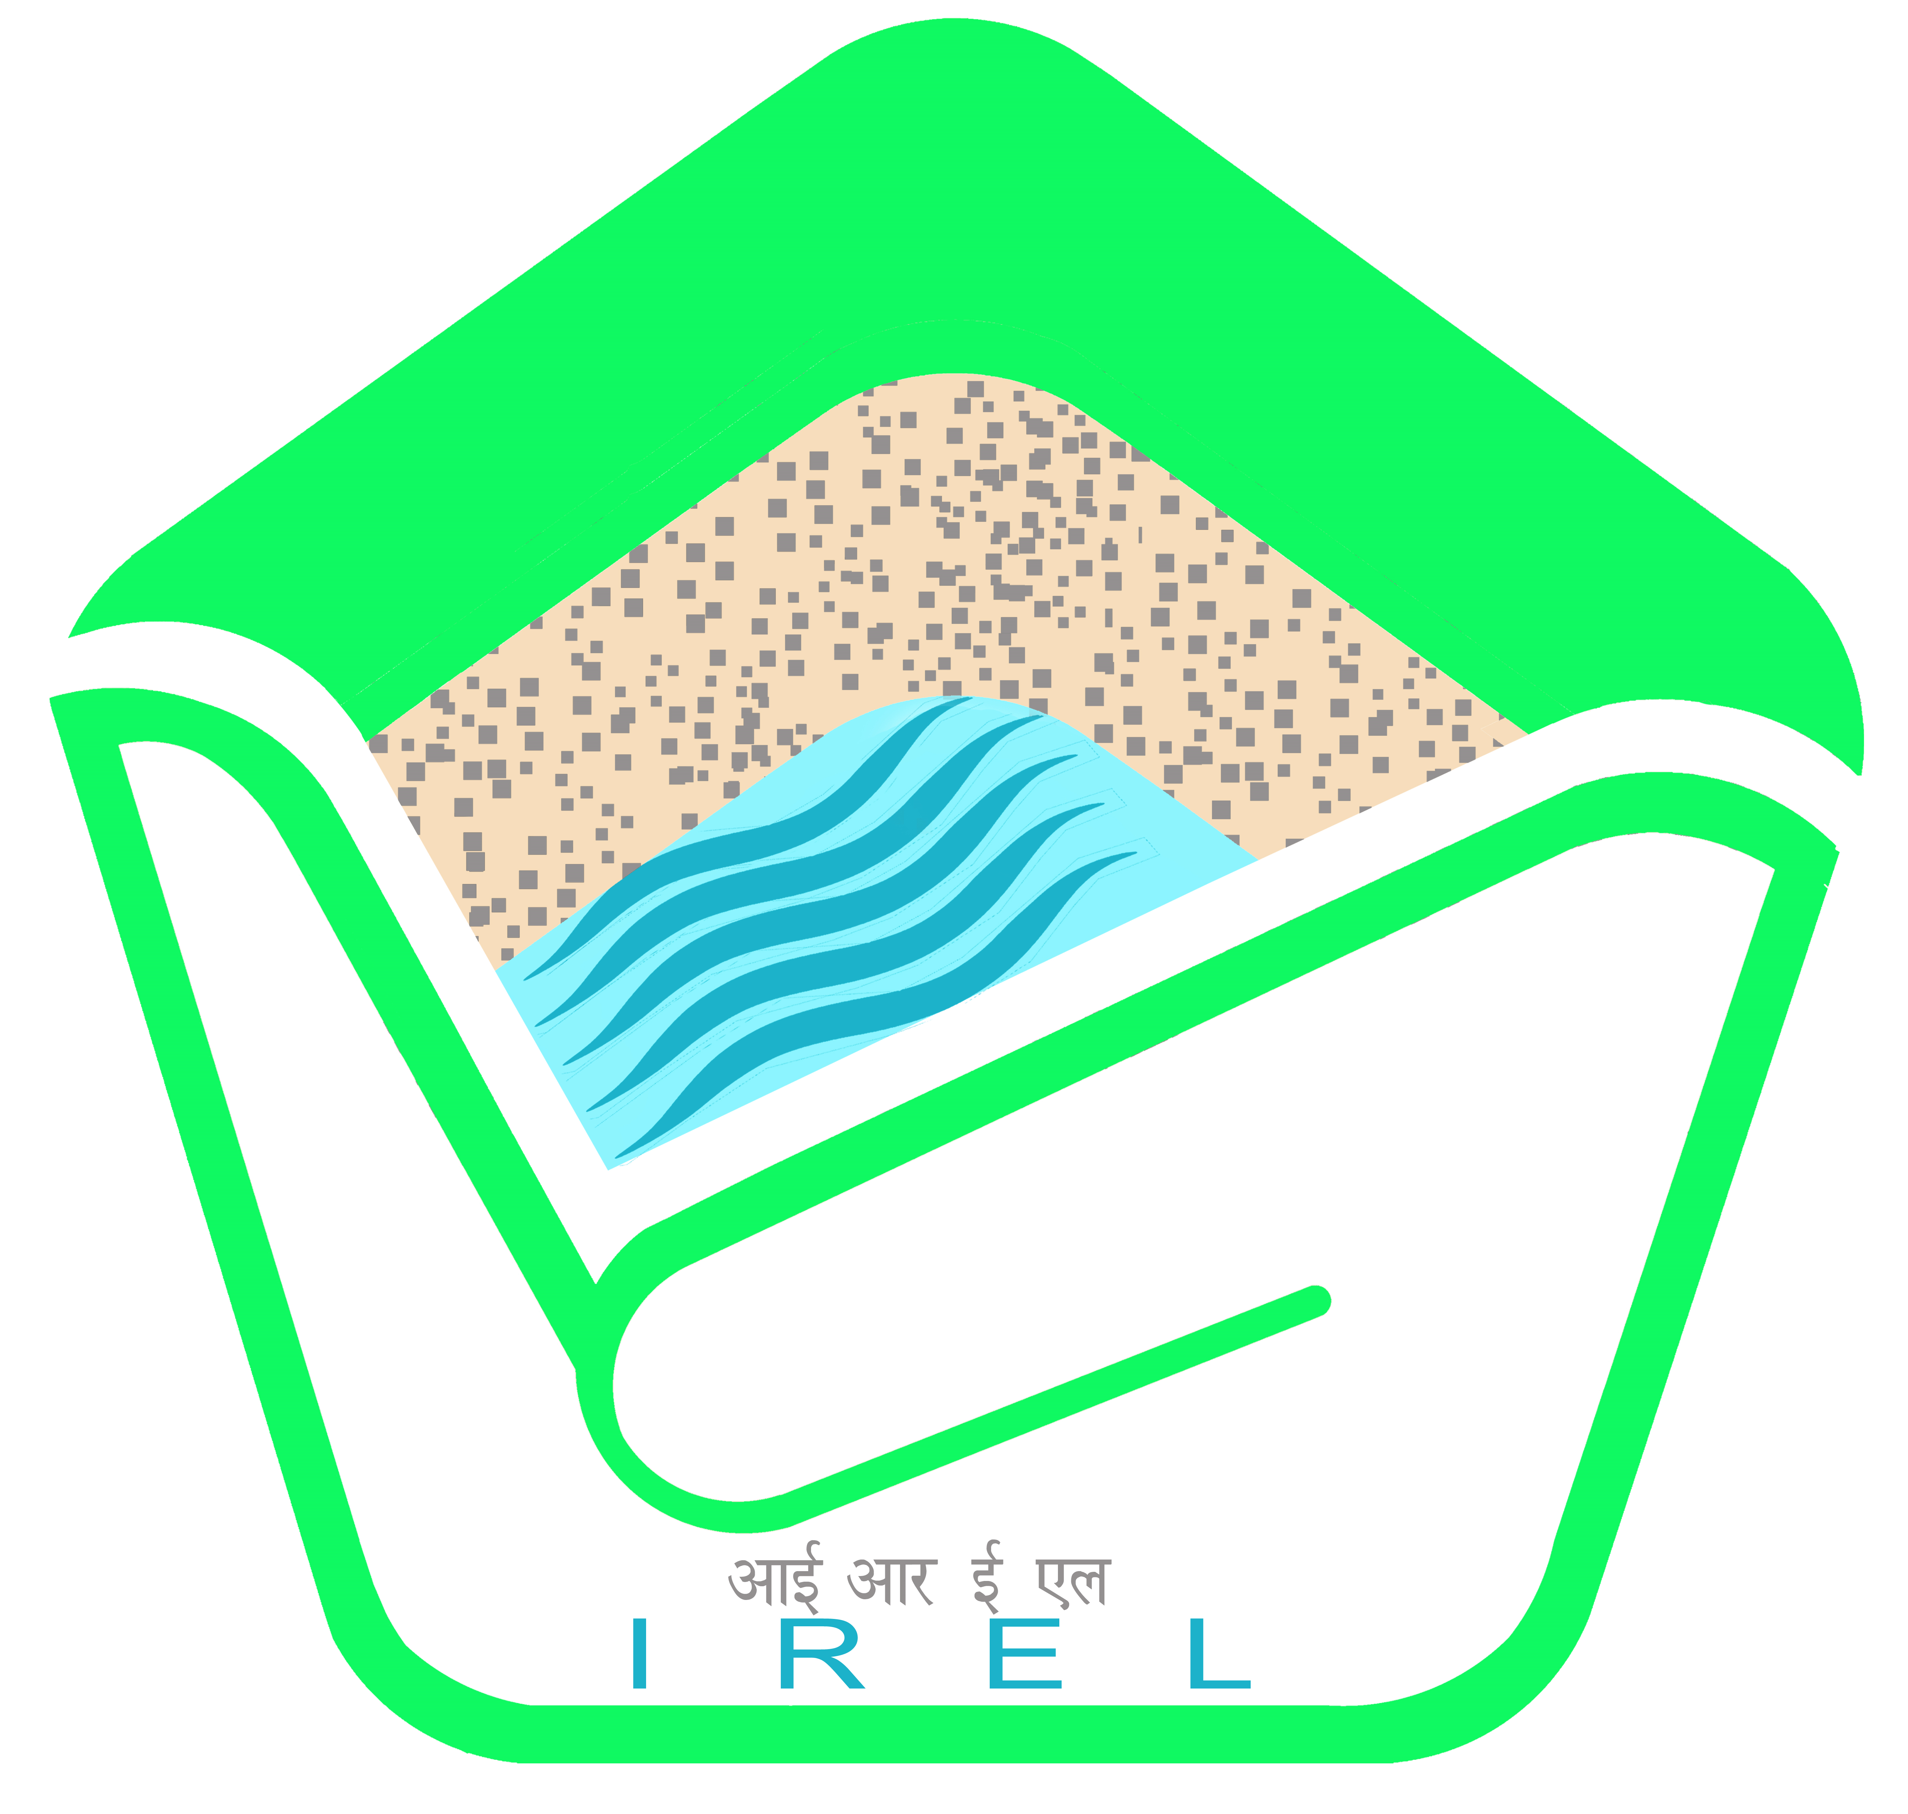  Unleashing Values   | 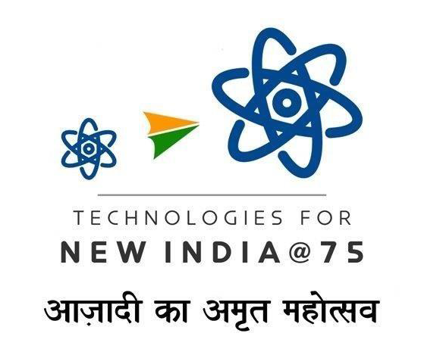  आईआरईएल (इंडिया) लिमिटेड  IREL (India) Limited  (Formerly Indian Rare Earths Limited)  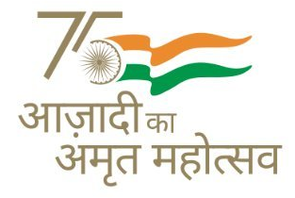  (भारत सरकार का उपक्रम)  (A Government of India Undertaking)  CIN : U15100MH1950GOI008187 Website : www.irel.co.in

ISO 9001: 2015, ISO 14001: 2015 & ISO 45001 : 2018 Company

CORRIGENDUM No: IV Dated - 10/03/2025

Item/ Job Description | Renovation work at TTI building to facilitate mining office
CPPP Tender ID | 2025_IREL_224928_1 Dated: 27/01/2025

Following Changes are hereby made
Document download / Sale End Date | 17/03/2025- 02:00 PM
Bid Submission End Date | 17/03/2025 - 02:00 PM
Bid Opening Date | 18/03/2025 - 02:30 PM

This tender is being processed through electronic bidding process in CPPP. Hence all documents should be uploaded to the CPPP site only.

All other tender techno commercial terms & conditions and scope remain unchanged.

All other terms and conditions of the tender shall remain unchanged. Please visit us at http://irel.co.in , www.etenders.gov.in for other details and further Corrigendum(s), if any.

-Sd/-
GM – T( Purchase) & I/C Marketing

